SpeedAC iQ – Add a new language

**N.B. *Need to download RTC CONFIGURATOR from the SpeedAc iQ Knowledge base**

**\*\*Work only with version V2.5.0 and up for Net, Gross and Duplex weigher!**

**\*\*Work only with version V3.1.0 and up for IP weigher!**

* Download the Excel file **SpeedACiQ_SpareLanguage.xlsm** from the SpeedAc iQ Knowledge base
* Open the file and fill it with the names corresponding to the **TX_** of the new language. (Refer to English file).



* And make sure to fill the entire **SpareLanguage** column (i.e)

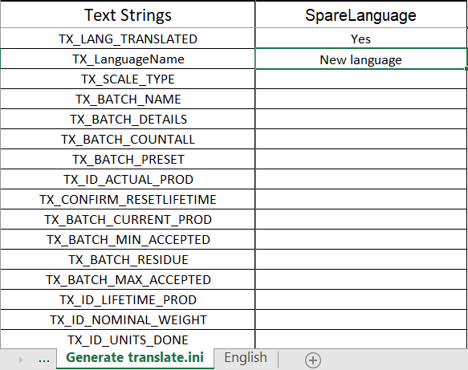

* Create a new folder in your **local** **disk C** called **TestTranslate.**
* Then click the button .ini to generate the file translation.ini.



* The file **translation.ini** will be in the folder indicated in the Excel file (**C:\TestTranslate**).





* Open RTC CONFIGURATOR and then connect the controller. Click on Device, select **FTP Browser**.

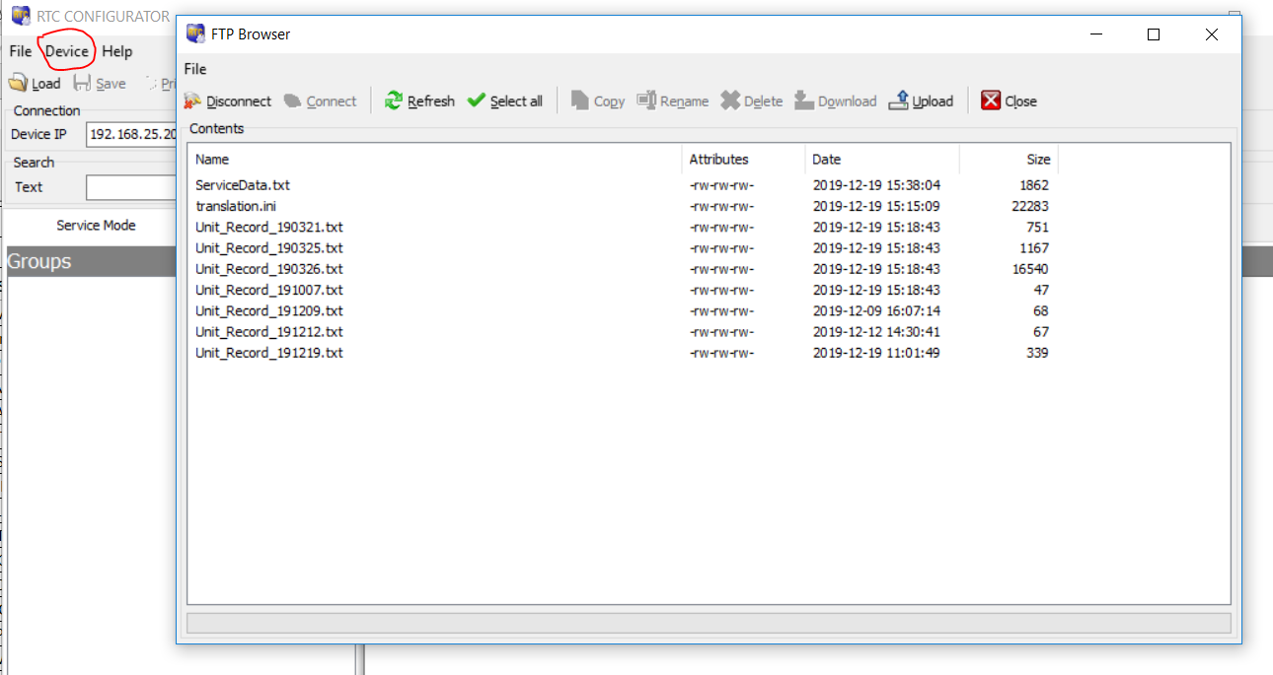

* Upload the file **translation.ini** and then restart the controller.

